This is the pre-peer reviewed version of the following article: “Taking advantage from phenotype variability in a local animal genetic resource: identification of genomic regions associated with the hairless phenotype in Casertana pigs” by Giuseppina Schiavo, Francesca Bertolini, Valerio Joe Utzeri, Anisa Ribani, Claudia Geraci, Laura Santoro, Cristina Óvilo, Ana I. Fernández, Maurizio Gallo and Luca Fontanesi, which has been published in final form at https://doi.org/10.1111/age.12665 . This article may be used for non-commercial purposes in accordance with Wiley Terms and Conditions for Self-Archiving."

SHORT COMMUNICATION

Taking advantage from phenotype variability in a local animal genetic resource: identification of genomic regions associated with the hairless phenotype in Casertana pigs

Giuseppina Schiavo^{1,*}, Francesca Bertolini^{1,2;*}, Valerio Joe Utzeri¹, Anisa Ribani¹, Claudia Geraci¹, Laura Santoro³, Cristina Óvilo⁴, Ana I. Fernández⁴, Maurizio Gallo⁵ and Luca Fontanesi¹

¹ Department of Agricultural and Food Sciences, Division of Animal Sciences, University of Bologna, Viale Fanin 46, 40127 Bologna, Italy
² Department of Animal Science, Iowa State University, 2255 Kildee Hall, 50011 Ames, Iowa, USA
³ ConSDABI - National Focal Point Italiano FAO, Contrada Piano Cappelle, 82100 Benevento, Italy
⁴ Departamento de Mejora Genética Animal, Instituto Nacional de Tecnología Agraria y Alimentaria (INIA), Ctra. de la Coruña km. 7.5, 28040 Madrid, Spain
⁵ Associazione Nazionale Allevatori Suini, Via L. Spallanzani 4, 00161 Roma, Italy

* These authors contributed equally to this work

Corresponding author: luca.fontanesi@unibo.it

Running title: Hairless in Casertana pigs
Summary
Casertana is an endangered autochthonous pig breed (raised in the Central-South of Italy) that is considered the descendant of the influential Neapolitan pig population that was used to improve British breeds in the 19th century. Casertana pigs are characterized by a typical, almost complete, hairless phenotype. Despite this phenotype is the characteristic trait of this breed, few Casertana pigs are normal-haired. In this work, using Illumina PorcineSNP60 BeadChip data, we carried out a genome wide association study (GWAS) and an F_{ST} analysis in this breed by comparing animals showing the classical hairless phenotype (n. 81) versus pigs classified as haired (n. 15). Combining results obtained with the two approaches, we identified two significant regions, one on porcine chromosome (SSC) 7 and one on SSC15. The SSC7 region contains the forkhead box N3 (FOXN3) gene, the most plausible candidate gene of this region, considering that mutations in another gene of the same family (forkhead box N1; Foxn1 or FOXN1) are responsible for the nude locus in rodents and alopecia in humans. Another potential candidate gene, Rho guanine nucleotide exchange factor 10 (ARHGEF10) is located on the SSC15 region. FOXN3 and ARHGEF10 have been detected as differentially expressed in androgenetic and senescent alopecia, respectively. This study in an autochthonous pig breed contributed to shed some lights on novel genes potentially involved in hair development and growth, demonstrating that local animal breeds can be valuable genetic resources to disclose genetic factors affecting unique traits, taking advantage from phenotype variability segregating in small populations.

Key words: alopecia, animal genetic resource, animal model, baldness, hairless, F_{ST}, GWAS, SNP.
Text
Local animal genetic resources might be characterized by specific and inheritable phenotypes with relevant importance for current or potential future use in breeding programs or for many other purposes, including the definition of new biological models or to understand mechanisms of biological adaptations to different environments (Leroy et al. 2016).
Casertana is an endangered autochthonous pig breed mainly raised in the Central-South of Italy, accounting for about 100 boars and sows currently registered to its herd book (ANAS 2016). Casertana pigs are usually raised in extensive or semi-extensive systems to produce niche pork products. This local breed is considered the descendant of the influential Neapolitan breed of the late 18th and 19th centuries that was used to improve British pig populations from which several modern commercial breeds were derived (Porter 1993). Casertana pigs are characterized by a black or grey coat colour, wrinkled skin, forward ears, two goatlike wattles (not always present) and a typical, almost complete, hairless phenotype not related to the age of the animals. This later characteristic is also reported in one of its local names, i.e. Pelatella (that means plucked or bald). Despite the hairless phenotype is the characteristic phenotype of this breed, Casertana population shows some variability for this trait, including animals having from almost complete absence of hairs (hairless; the most common pigs) to few animals having abundant hairs (normal-haired pigs; Figure 1a). The hairless phenotype is also present in other pig breeds like the Creole hairless Mexican breed (also known as Pelón Mexicano) and the black hairless Iberian strains, including the Guadyerbas strain maintained as isolated population (Toro et al. 2000; Lemus-Flores et al. 2001). Casertana and all these other hairless pigs seem historically connected through exchange of pig genetic material determined by commercial activities in the 18th and 19th centuries (Porter 1993), suggesting a potential common origin of the hairless phenotype.
Hairless or hairlessness in pigs can be better described as hypotrichosis or congenital deficiency of hairs, as animals classified as “hairless” usually show a small number rather than a complete absence of hairs. Roberts & Carroll (1931) were the first authors that reported a possible inheritance model for this hypotrichotic condition in Mexican pigs, suggesting the presence of a monogenic autosomal factor with a recessive mutated h allele that could give the hairless phenotype when homozygous. Homozygous pigs for the wild type allele H might be normal-haired whereas heterozygous Hh pigs might show an intermediate phenotype. This early study was not followed by any other genetic investigations on the hairless condition in pigs. More recently, variability in the porcine hairless gene (known as HR, lysine demethylase and nuclear receptor corepressor), located on porcine chromosome (SSC) 14, was evaluated in a candidate gene approach to study the hairless phenotype in Iberian pigs but no association with this trait was reported (Fernández et al. 2003, 2006). Mutations in the HR gene have been shown to impair hair growth in different mammals (i.e. Stoye et al. 1988; Ahmad et al. 1998; Finocchiaro et al. 2003). A high number of other genes in humans and rodents have been implicated in abnormal hair development and hypotrichosis (Shimomura & Christiano 2010; Ramot & Zlotogorski 2015), making impractical a candidate gene approach to successfully identify polymorphisms associated with the hairless phenotype in pig populations.
In this work, with the aim to restrict the number of potential causative genes involved in the hypotrichotic phenotype in pigs, we carried out a genome wide association study (GWAS) and a genome wide F_{ST} analysis in the Casertana breed by comparing animals showing the classical hairless phenotype (n. 81, 35 males and 46 females) versus pigs classified as haired (n. 15, 7 males and 8 females; a quite rare phenotype in this breed), without any distinction between possible different hair levels that could not be precisely recorded in outdoor animals. Casertana breed offers a unique possibility to investigate this phenotype that is segregating within the same population. This is one of the first population based genome wide study in a local pig breed that is not only useful to characterize a breed specific trait but also to obtain basic biology information that could be important to better define an interesting animal model for alopecia or related phenotypes in humans (Shimomura 2012).
Blood or hair roots were collected from all these Casertana pigs raised in six different farms located in the Campania and Molise regions (Central-South of Italy), having from 5 to 49 pigs each, with unknown relationships. A two tailed chi-square analyses with Yates correction confirmed that the occurrence of the observed phenotypes is not associated to the sex in the sampled animals (P>0.10). Extracted DNA was used for genotyping with the Illumina PorcineSNP60 BeadChip v.2 (Illumina, Inc., San Diego, CA, USA) interrogating 61,565 single nucleotide polymorphisms (SNPs). Genotyping data were processed with PLINK 1.9 software (Chang et al. 2015) using the following criteria to filter SNPs: call rate >0.9, minor allele frequency >0.01 and Hardy-Weinberg equilibrium P>0.001. A total of 36,533 autosomal SNPs, assigned to a unique position in the Sscrofa11.1 genome version, were used for multidimensional scaling (MDS) obtained with the PLINK 1.9 software (Chang et al. 2015) to evidence distance relationships among the animals of the investigated cohort. The obtained MDS plot showed some structures not well defined in the analysed pigs that however did not clearly separate the two Casertana groups (i.e. hairless and haired; Figure S1).
Genome wide association study was then carried out using the filtered SNPs by applying the univariate mixed model of GEMMA to be able to correct for population relatedness and possible clusterisation (Zhou & Stephens 2012). The centered relatedness matrix calculated from SNP genotypes was included in the model to correct for population stratification. Figure S2 reports the genomic inflation factor (λ) and quantile–quantile (Q–Q) plot, obtained with GenABEL (Aulchenko et al. 2007). Figure 1b reports the Manhattan plot produced in this GWAS. Relevant data reported in this work have been submitted to the Zenodo digital repository. At the P<0.05 Bonferroni corrected level (P nominal value < 1.37E-06), three SNPs were significant whereas at the P<0.1 Bonferroni corrected threshold (P nominal value = 2.74E-06) other three SNPs were suggestively significant (Table 1). Two of these SNPs were located on SSC7 (170.17 kb apart) and four on SSC15, in two distinct regions of approximately 1.14 Mb and 338.61 kb.
F_{ST} analysis was performed on the same dataset using PLINK 1.9 software (Chang et al. 2015). Missing SNPs were imputed using the Beagle 3.3.2 software (Browning and Browning, 2009). Figure 1c reported the Manhattan plot of the F_{ST} analysis. The top 0.9998 SNPs of the percentile distribution (F_{ST}=0.345) were considered as the most divergent across the comparison and therefore retained for subsequent evaluation (Table 1). A total of 8 SNPs was above the selected threshold: one on SSC4, one on SSC2, two on SSC7 (170.17 kb apart), two on SSC15 (1.14 Mb apart) and two on SSC17 (32.00 kb apart).
The comparison among GEMMA and F_{ST} genome-wide analyses identified two overlapping regions encompassing two SNPs on SSC7 and two SNPs on SSC15 that constituted the 1.14 Mb region previously mentioned (Table 1). A total of eight and nine genes were annotated in the SSC7 and SSC15 regions, respectively (in a window ±500 kb from the first and the last SNPs; Table 1). The most plausible candidate gene in the SSC7 region was the forkhead box N3 (FOXN3) gene (position: 111036492-111454106 bp), that is 66.56 kb far from INRA0028322 (one of the two most significant SNPs in the GWAS; Table 1). This gene has a role in the regulation of hepatic glucose utilization (Karanth et al. 2016), craniofacial development (Samaan et al. 2010) and growth and migration of colon cancer cells (Dai et al. 2017). The FOXN3 gene was also found differentially expressed in a case-control study for androgenetic alopecia in humans (Mirmirani & Karnik 2010). Forkhead box proteins constitute a family of transcription factors involved in embryo and fetal development and function of adult organisms (Hannenhalli & Kaestner 2009). This group of proteins list about 50 members in mammals, divided in 19 subfamilies indicated with the letters from A to S (Jackson et al. 2010; Benayoun et al. 2011). Among the N subfamily, forkhead box N1 (FOXN1) regulates keratin gene expression and the gene (Foxn1) is responsible for the nude locus in rodents (Flanagan 1966; Meier et al. 1999). Mutations in this gene determine hairlessness, alopecia and other pleiotropic effects in mice and rats (Nehls et al. 1994) and congenital alopecia, nail dystrophy, and primary T-cell immunodeficiency in humans (Frank et al. 1999). Therefore, considering the phylogenetic relationships and the partially conserved domains between the FOXN1 and FOXN3 genes (Benayoun et al. 2011), it seems plausible that FOXN3 might have conserved similar regulatory functions of FOXN1 that could explain the effect of this SSC7 chromosome region on the hairless phenotype in Casertana pigs. This indication might contribute to understand the involvement of forkhead box proteins in hair development and, if confirmed by functional studies, adds another candidate gene to the list of those potentially involved in alopecia and baldness.
No strong candidate gene could be identified in the SSC15 region. A possible candidate could be Rho Guanine Nucleotide Exchange Factor 10 (ARHGEF10) gene. ARHGEF10 is involved in neural morphogenesis and connectivity and in the regulation of small RhoGTPases (Verhoeven et al. 2003). The ARHGEF10 has been reported to be differentially expressed in a case-control study of senescent alopecia in human (Mirmirani & Karnik 2010), supporting, to some extent, its possible role in the hairless phenotype in the Casertana breed. According to the available functional information, no other gene in the two identified regions might be involved in hair or follicle development or phenotypes similar to the hairless condition we investigated.
The combination of the GWAS and F_{ST} results with the annotated gene functions was useful to draft a possible biological explanation of the hairless phenotype in Casertana pigs and to identify significant regions, excluding other regions that reached or were close to the defined thresholds in one or the other genome wide investigation methods derived by several confounding factors that could not be better managed in our study (i.e. genetic drift, population structure, ascertain bias of the SNP chip tool). However, the results obtained in this breed, even if based on a small group of pigs with normal-haired phenotype (that is a quite rare in this breed) in contrast with the hairless group, seems to support the presence of more than one locus affecting this trait. A few of the associated genomic regions contain candidate genes that, based on their function or inferred function may be involved in the hypotricotic condition of the Casertana pigs, with the hypothesis that this trait might be more complex than previously suggested.
This study adds another contribution to the genetic characterization of morphological traits in pigs that have been reported to describe breed specific phenotypes (i.e. ear size and coat colours) in other autochthonous populations (i.e. Ren et al. 2011; Fontanesi et al. 2016). This work demonstrated that endangered animal genetic resources could be investigated to disclose genetic factors affecting unique traits taking advantage from phenotype variability segregating within a small population. Other investigations are needed to refine these results obtained in Casertana and to evaluate if the hairless condition in other pig breeds is derived by the same genetic factors identified in this study.

Competing interests
The authors declare that they do not have competing interests. Data reported in this work can be shared after signature of an agreement on their use with University of Bologna.

Acknowledgements
This work has received funding from the Italian Ministry of Agriculture, Food and Forestry (MiPAAF) under the project INNOVAGEN and from the European Union’s Horizon 2020 research and innovation programme under grant agreement No 634476 (Project acronym: TREASURE). The content of this paper reflects only the authors’ view and the European Union Agency is not responsible for any use that may be made of the information it contains.

References
Ahmad W., Haque M.F., Brancolini V., et al. (1998) Alopecia universalis associated with a mutation in the human hairless gene. Science 219, 720-4.
ANAS (2016) Registro Anagrafico. http://www.anas.it/.
Aulchenko Y.S., Ripke S., Isaacs A. & van Duijn C.M. (2007) GenABEL: an R library for genome-wide association analysis. Bioinformatics 23, 1294-6.
Benayoun B.A., Caburet, S. & Veitia R.A. (2011) Forkhead transcription factors: key players in health and disease. Trends in Genetics 27, 224-32.
Browning B.L. & Browning S.R. (2009) A unified approach to genotype imputation and haplotype phase inference for large data sets of trios and unrelated individuals. American Journal of Human Genetics 84, 210-23.
Chang C.C., Chow C.C., Tellier L.C., Vattikuti S., Purcell S.M. & Lee J.J. (2015) Second-generation PLINK: rising to the challenge of larger and richer datasets. Gigascience 4:7.
Dai Y., Wang M., Wu H., Xiao M., Liu H. & Zhang D. (2017) Loss of FOXN3 in colon cancer activates beta-catenin/TCF signaling and promotes the growth and migration of cancer cells. Oncotarget 8, 9783-93.
Fernández A., Silió L., Noguera JL., Sánchez A. & Óvilo C. (2003) Linkage mapping of the porcine hairless gene (HR) to chromosome 14. Animal Genetics 34, 317-8.
Fernández A.I., Silió L. & Óvilo C. (2006) Caracterization del gen hairless, candidato para el fenotipo lampino caracteristico de una variedad de cerdo Ibérico. Proceedings of the XIII Reunión Nacional de Mejora Genética Animal, 28-30 June 2006, Gijón. Spain.
Finocchiaro R., Portolano B., Damiani G., et al. (2003) The hairless (hr) gene is involved in the congenital hypotrichosis of Valle del Belice sheep. Genetics Selection and Evolution 35, S147-56.
Fontanesi L., Scotti E., Gallo M., Nanni Costa L. & Dall'Olio S. (2016) Authentication of “mono-breed” pork products: Identification of a coat colour gene marker in Cinta Senese pigs useful to this purpose. Livestock Science 184, 71-7.
Flanagan S.P. (1966) ‘Nude’ a new hairless gene with pleiotropic effects in the mouse. Genetic Research 8, 295-309.
Frank J., Pignata C., Panteleyev A.A., et al. (1999) Exposing the human nude phenotype. Nature 398:473-4.
Hannenhalli S. & Kaestner K.H. (2009) The evolution of Fox genes and their role in development and disease. Nature Reviews Genetics 10, 233-40.
Jackson B.C., Carpenter C., Nebert D.W. & Vasiliou V. (2010) Update of human and mouse forkhead box (FOX) gene families. Human Genomics 4, 345-52.
Karanth S., Zinkhan E.K., Hill J.T., Yost H.J. & Schlegel A. (2016) FOXN3 regulates hepatic glucose utilization. Cell Reports 15, 2745-55.
Lemus-Flores C., Ulloa-Arvizu R., Ramos-Kuri M., Estrada F.J. & Alonso R.A. (2001) Genetic analysis of Mexican hairless pig populations. Journal of Animal Science 79, 3021-6.
Leroy G., Besbes B., Boettcher P., Hoffmann I., Capitan A. & Baumung R. (2016) Rare phenotypes in domestic animals: unique resources for multiple applications. Animal Genetics 47, 141-53.
Meier N., Dear T.N. & Boehm T. (1999) Whn and mHa3 are components of the genetic hierarchy controlling hair follicle differentiation. Mechanisms of Development 89, 215-21.
Mirmirani P. & Karnik P. (2010) Comparative gene expression profiling of senescent and androgenetic alopecia using microarray analysis. In: Aging Hair. (Trueb R.M. & Tobin D.J., eds), New York: Springer, pp. 67–76.
Nehls M., Pfeifer D., Schorpp M., Hedrich H. & Boehm T. (1994) New member of the winged-helix protein family disrupted in mouse and rat nude mutations. Nature 372, 103-7.
Porter V. (1993) Pigs: A Handbooks to the Breeds of the World. Cornell University Press,
Ramot Y. & Zlotogorski A. (2015) Molecular genetics of alopecias. Current Problems in Dermatology 47, 87-96.
Ren J., Duan Y., Qiao R., et al. (2011) A missense mutation in PPARD causes a major QTL effect on ear size in pigs. PLoS Genetics 7, e1002043.
Roberts E. & Carroll W.E. (1931) The inheritance of hairlessness in swine. Journal of Heredity 22, 125-32.
Samaan G., Yugo D., Rajagopalan S., et al. (2010) Foxn3 is essential for craniofacial development in mice and a putative candidate involved in human congenital craniofacial defects. Biochemistry Biophysics Research Communications 400, 60-5.
Shimomura Y. (2012) Congenital hair loss disorders: rare, but not too rare. Journal of Dermatology 39, 3-10.
Shimomura Y. & Christiano A.M. (2010) Biology and genetics of hair. Annual Review of Genomics and Human Genetics 11, 109-32.
Stoye J.P., Fenner S., Greenoak G.E., Moran C. & Coffin J.M. (1988) Role of endogenous retroviruses as mutagens: the hairless mutation of mice. Cell 54, 383-91.
Toro M.A., Rodriganez J., Silio L. & Rodriguez C. (2000) Genealogical analysis of a closed herd of black hairless Iberian pigs. Conservation Biology 14, 1843-51.
Verhoeven K., De Jonghe P., Van de Putte T., et al. (2003) Slowed conduction and thin myelination of peripheral nerves associated with mutant rho Guanine-nucleotide exchange factor 10. American Journal of Human Genetics 3, 926-32.
Zhou X. & Stephens M. (2012) Genome-wide efficient mixed-model analysis for association studies. Nature Genetics 44, 821-4.
Figure 1. Casertana pigs and results of the genome wide association study (GWAS). a) Casertana pigs with the hairless (left) and haired (right) phenotypes. b) Manhattan plot of the GWAS results showing Bonferroni significant (red line: P<0.05) and suggestively significant (blue line: P<0.10) single nucleotide polymorphisms (SNPs; thresholds are Bonferroni corrected P values). c) F_{ST} plot. Single nucleotide polymorphisms above the red line (F_{ST}=0.345) are the top 0.9998 SNPs.

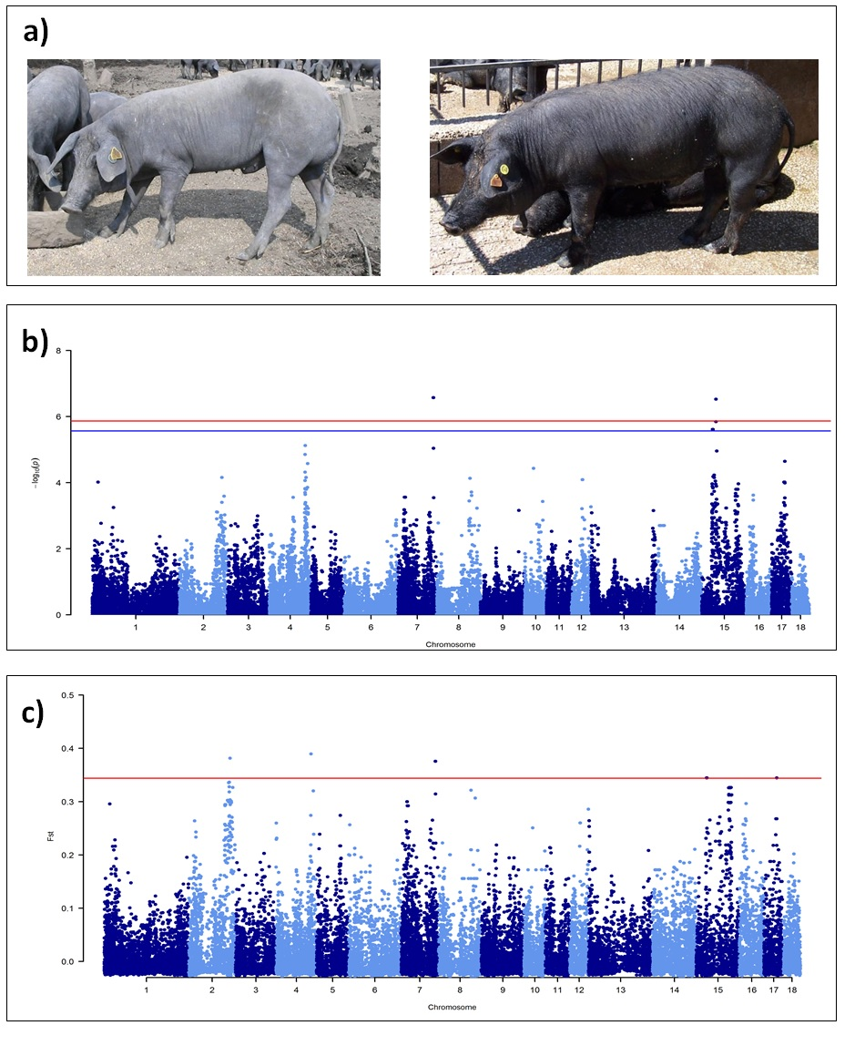

Table 1. List of significant (P<0.05) and suggestively significant (0.05<P<0.10; Bonferroni corrected) single nucleotide polymorphisms (SNPs) obtained in the genome wide association study (GWAS) in the Casertana pigs (GEMMA) and the top 0.998 detected in the F_{ST} analysis. For the overlapping regions among the two approaches, annotated genes nearby the SNPs (±500 kb from the first to the last SNP of the region) were reported (Sscrofa11.1 genome version). The candidate genes that could be involved in the hair phenotype are indicated with the “*” symbol. P, F_{ST} and annotated genes are reported only for the SNPs and regions for which both P and F_{ST} values trespassed the indicated thresholds.
SSC | SNP | position | GWAS, P nominal value | F_{ST} value | Annotated genes
2 | ALGA0016212 | 134598604 | - | 0.381 | -
4 | INRA0016870 | 113277535 | - | 0.390 | -
7 | INRA0028322 | 111520662 | 2.68E-07 | 0.376 | LOC106504536, PSMC1, EFCAB11, NRDE2, CALM1, TDP1, KCNK13, FOXN3*
7 | ALGA0044817 | 111690832 | 2.68E-07 | 0.376
15 | MARC0009352 | 33679138 | 2.45E-06 | 0.345 | C110257074, CLN8, KBTBD11, DLGAP2, LOC106509653, ARHGEF10*, LOC106506202, CSMD1, MYOM2
15 | ALGA0084906 | 34793592 | 2.45E-06 | 0.345
15 | H3GA0044265 | 44006149 | 3.00E-07 | - | -
15 | INRA0049225 | 44344760 | 1.43E-06 | - | -
17 | DRGA0016747 | 41675886 | - | 0.345 | -
17 | H3GA0049027 | 41643251 | - | 0.345 | -

Figure S1. Multidimensional scaling (MDS) plot of hairless (red spots) and haired (black spots) pigs, on the first and second dimension.

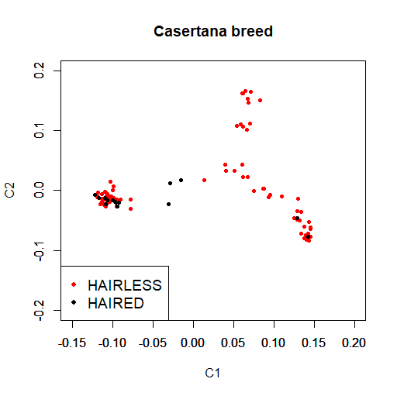

Figure S2. Q-Q plot.
